Authoring set up

# Introduction

[The Content Interface](https://djplaner.github.io/Content-Interface-Tweak/) provides a way of authoring content for Blackboard course sites.

This page has the following sections

1. Why? Improve the authoring process and the quality of Blackboard content.
2. What? Author using Microsoft Word and add functionality.
3. How? Configure you course site, computer, and web browser

# Why? Improve the authoring process and the quality of Blackboard content

To answer this question, the following explains how authoring typically works with Blackboard, and some of the problems with this approach.

## How authoring normally works

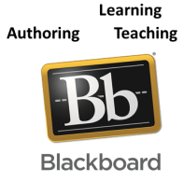

Blackboard provides a range of standard [content containers](https://help.blackboard.com/Learn/Instructor/Original/Course_Content/Create_Content/Create_Course_Materials/Create_Content_Items_or_Documents) that can be used to author and maintain content.

All of these content containers use [the same browser-based content editor](https://help.blackboard.com/Learn/Administrator/Hosting/Tools_Management/Content_Editor). i.e. to make changes you must do so through your Web browser.

Most people don’t do this. This is not how most people create content.

Instead, most people create content using common applications such as Microsoft Word and PowerPoint. Perhaps creating PDFs or other files that are uploaded into Blackboard. Perhaps copy and pasting content from these applications into the Blackboard editor.

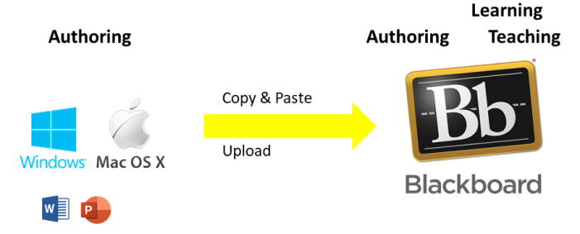

## Problems with authoring this way

The following is just one small sample of the problems with they typical authoring process.

### Copy and paste doesn’t work

Copy and pasting from Word is [known not work very well](https://help.blackboard.com/Learn/Student/Original/Add_and_Format_Content/Work_with_Text). It requires various work arounds. Even if you ignore those workarounds it is still a very manual process.

### Formatting is “surprising”

Even if you’re entering text directly into the text editor can [bring formatting surprises](https://twitter.com/merylkenny/status/1428369855355396096)

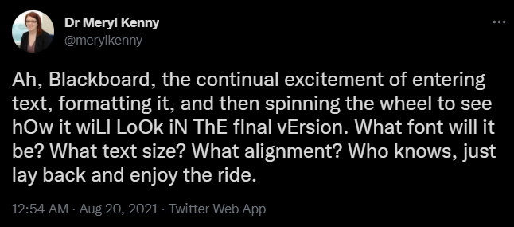

### It’s just a text editor, not a content authoring tool

The Blackboard content editor is a fairly useful text editor. But, it doesn’t provide any higher level functionality typically expected with content authoring. A small list includes: no spelling or grammar checking, no version control, no support for collaborative authoring, and very limited styling and templating.

It also provides very limited functionality specific to course content. One example is university dates (e.g. when is assignment 1 due). With Blackboard, such contextual information needs to be manually by the author. Creating a maintenance task that needs to be performed each time a course is offered. An alternative is to leave out dates and expect the students to figure out the dates.

### Low usability and functional limitations

Blackboard Learn has several functional limitations in legibility, design consistency, content arrangement and content adjustment that make it difficult to achieve quality visual design ([Bartuskova, Krejcar, & Soukal, 2015](https://www.researchgate.net/publication/300349488_Framework_of_Design_Requirements_for_E-learning_Applied_on_Blackboard_Learning_System)). Usability analysis has also found that the Blackboard content area is inflexible, inefficient to use, and creates confusion for teaching staff regardless of their level of user experience ([Kunene & Petrides, 2017](https://www.semanticscholar.org/paper/Mind-the-LMS-Content-Producer-%3A-Blackboard-for-and-Kunene-Petrides/b61ba09403c8825e58d3e64c2ae46b762cf4e34a)).

# What? Author using Microsoft Word and add functionality

The Content Interface automates and adds functionality to the way most people author content. You continue to write original content using Microsoft Word to edit Word documents hosted on a shared drive.

The Content Interface then automates the process of updating Blackboard pages with the content of those Word documents. As it updates Blackboard, the Content Interface transforms your content to improve the design and functionality for the reader.

The shared drive can also be used to share other resources with students.

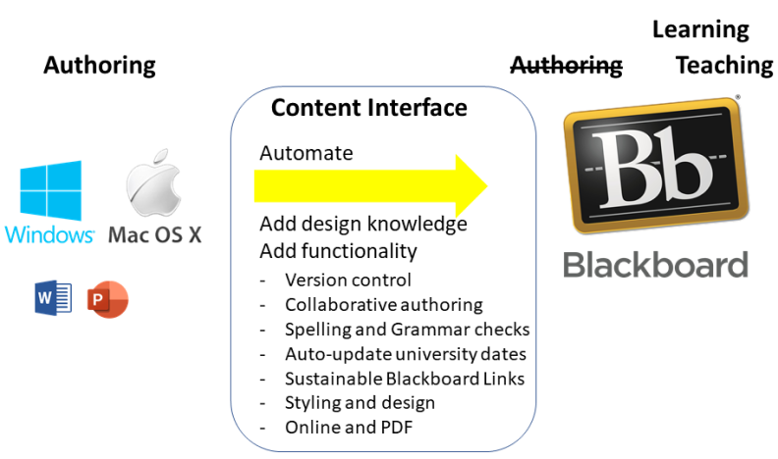

# How? Configure you course site, computer, and web browser

The Content Interface can be used in a variety of ways. The following focuses on the most useful method – the “automated approach”.

To use the automated approach you will:

1. Link your Blackboard course site with a shared folder.  
   The shared folder is where your course content sits. Linking Blackboard with the shared folder allows automated updating of Blackboard content from the Word documents in the shared folder.
2. Link your computer with the shared folder.  
   Your course content sits in the shared folder. Linking your computer with the shared folder allows you to you to create and edit the course content as if it were a normal folder on your computer.
3. Configure your web browser – adding an extension and userscript  
   With the links established you now need to update content in Blackboard from the Word documents in the shared folder. You can do this manually. Or, you can configure your web browser so that it automates the process.

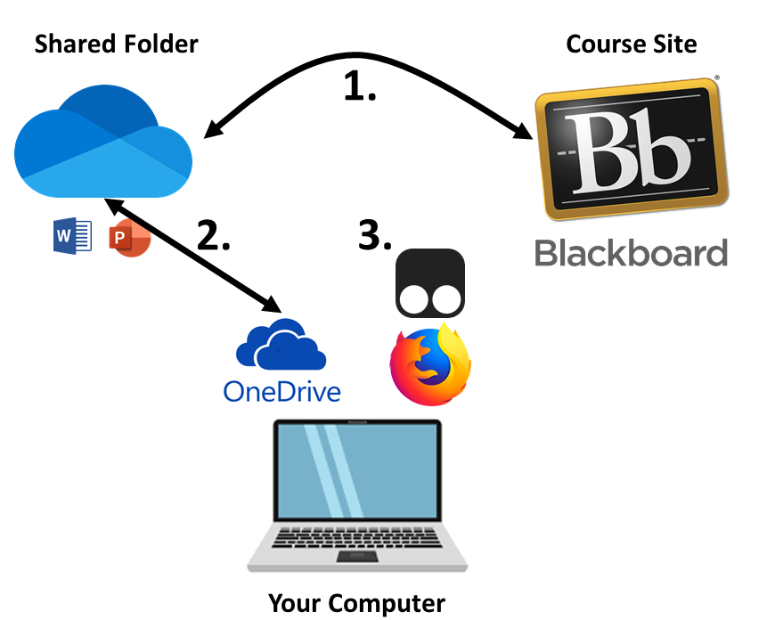

## 1. Link your Blackboard course site with a shared folder

In some instances (e.g. you’re working with a Learning & Teaching Consultant), this step may already be completed for you.

This step helps automate the content update process. There are three sub-steps.

### 1.1 Create a Microsoft shared (cloud) folder (do this once)

A shared (aka cloud) folder provides a space for working with and sharing computer files that is located on a cloud service. i.e. a service that can be used from different devices, perhaps with different people.

Microsoft provides a number of different (somewhat interrelated) ways to create a shared folders: [OneDrive](https://support.microsoft.com/en-us/office/share-onedrive-files-and-folders-9fcc2f7d-de0c-4cec-93b0-a82024800c07), [SharePoint](https://support.microsoft.com/en-us/office/share-sharepoint-files-or-folders-1fe37332-0f9a-4719-970e-d2578da4941c) and [Microsoft Teams](https://support.microsoft.com/en-us/office/share-a-folder-from-cloud-storage-in-teams-988f8305-a0e2-44d8-9246-fcca7dd32e93) (which is typically done using SharePoint).

Please refer to Microsoft’s documentation for creating a shared folder.

### 1.2 Create a Word document for each Blackboard page

Each Blackboard page you will be authoring content for will need a matching Word document. The Word document is where you will author content.

**Start with the example document**

The [Content Interface example document](https://github.com/djplaner/Content-Interface-Tweak/raw/master/Example.docx) includes the pre-defined Word styles supported by the Content Interface. Using this example document as the starting place will save you time.

### 1.3 Link each Blackboard page with the matching Word document

Each Blackboard page must link appropriately to the matching Word document. This is done by [adding a *Content Document* item to the Blackboard page](https://djplaner.github.io/Content-Interface-Tweak/using/setup/#3-add-the-content-document-item).

## 2. Link your computer with the shared folder

To author content easily you need to be able to create and edit files and documents contained within the shared folder.

To do this you need to:

1. [Install OneDrive](https://www.microsoft.com/en-au/microsoft-365/onedrive/download) on your computer (or device).
2. [Sync the shared folder](https://support.microsoft.com/en-us/office/add-and-sync-shared-folders-to-onedrive-for-home-8a63cd47-1526-4cd8-bd09-ee3f9bfc1504) with your computer.

If you are using a Griffith University computer, then OneDrive will already be installed.

See [*Syncing the shared folder*](https://djplaner.github.io/Content-Interface-Tweak/using/syncSharedFolder/) for an expanded explanation of how to do this.

## 3. Configure your web browser – adding an extension and a userscript

With the Blackboard page linked to a matching Word document it is possible to update the Blackboard page with content from the Word document.

If you don’t configure your web browser [the update process is semi-automated](https://djplaner.github.io/Content-Interface-Tweak/using/createAndModify/#semi-automated-three-step-process).

To automate the update process, you need to add to your browser [an extension (TamperMonkey)](https://www.tampermonkey.net/) and [the Content Interface auto update userscript](https://github.com/djplaner/Content-Interface-Tweak/raw/master/userScripts/ciAutoUpdate.user.js).

For an expanded explanation of how to configure your web browser, view [*How to automate the process*](https://djplaner.github.io/Content-Interface-Tweak/using/automatingUpdates/#how-to-automate-the-process).

If possible, avoid using Chrome.

Almost any browser will work, however, Chrome is known to have problems if your content has a large file size (e.g. it has lots of different images, or a few very big images).